**Interview Questions and Answers**

**1. What is SAP HANA?**

HANA - High-Performance Analytical Appliance

SAP HANA is an in-memory, column-oriented, relational database management that combines OLAP and OLTP operations into a single system.

It performs analytics such as text search, text analytics, predictive analytics, spatial data processing, etc.

It includes extract, transform, load (ETL) capabilities as well as an application server.

**2. What are the main features of SAP HANA?**

***In-memory Database:***

With SAP HANA, you can now store the complete database in memory. This means that disk movement is not needed and swapping can be eliminated. Hence increase in the speed of read-write access.

***Multicore CPU and parallel processing:***

To get the best performance from new advanced hardware, SAP HANA makes use of parallelism by using all the cores of a CPU, and several CPUs.

Column store tables are automatically processed in parallel.

Even the same column can be split up and processed by different cores at the same time.

***Column and Row storage:***

SAP HANA supports both col and row store tables

By accessing data in column-store order, you benefit immensely from simplified table scan and data pre-caching. This can make all the difference in performance.

With column store, SAP HANA scans columns of data so quickly that additional indexes are usually not required.

It is easy to alter column store tables without dropping and reloading data.

Column store tables are optimal for parallel processing, as each core is able to work on a different column.

***Data Compression***

SAP HANA uses a dictionary per column

Operates directly on compressed data using integers

It reduces the amount of memory required.

It speeds up operations on columns because the columns can be loaded into the CPU caches faster and with fewer loading cycles.

***Aggregates and Indexes.***

Using the power of SAP HANA, you can aggregate on the fly from any line item table. You do not need prebuilt aggregates.

SAP HANA organizes data using column stores, which means that indexes are not needed. They can still be created but offer little improvement.

**3. What is the in-memory database?**

Storing data in main memory rather than on disk provides faster data access, faster querying and processing.

SAP HANA uses Dynamic tiering, frequently accessed "hot" data is stored on main memory and less frequently accessed "warm" data is stored on disk.

**4. Advantages of column store over row store?**

you benefit immensely from simplified table scan and data pre-caching.

only the required columns are loaded to memory, so you avoid using up memory with columns that will never be used

the data is arranged efficiently with all values of a column appearing one after another. This continuous sequencing of the column values is preferred by the CPU.

It is easy to alter column store tables without dropping and reloading data.

**5. What is code push down?**

To beneﬁt the most from SAP HANA's capabilities, it is necessary to change the programming paradigm as well as the traditional application design.

In traditional ABAP coding, it is standard practice to limit hits to the database by bringing in as much data as possible initially, then performing operations on this data. Although retrieving large amounts of data from the database is time-consuming, this approach was superior to hitting the database multiple times. Once we have the data within our program (whether it be in variables, internal tables, or your preferred data structure type), we perform operations to produce a file, report, or output.

Instead of gathering huge chunks of data and operating on it with ABAP coding logic, HANA’s capabilities insist that you perform data-intensive operations to be performed in the database layer itself. To achieve optimal speeds, it makes more sense to “push down” your coding logic to the database layer. Once the data-intensive operation is performed, only the result would be transferred and used within your ABAP program.

**6. Guidelines to increase ABAP code performance on SAP HANA database?**

* Keep result set small.
* Minimize the number of data transfer.
* Minimize number of database accesses.
* Minimize search overhead.
* Keep unnecessary load away from database.

**7. What are new repository objects?**

DDL data definition language - used to create/change/delete

DCL data control language - Security and access of data

**8. Explain CDS-related Repository Objects?**

***Data Deﬁnition :***

Also referred to as DDL Source (for Data Deﬁnition Language, named after the DDL part of SQL)

Contains the deﬁnition of either a CDS View or a CDS Table function

Display only in ABAP workbench

Editing requires the use of the ABAP Development Tool (ADT in Eclipse)

***Access Control :***

Also referred to as DCL Source (for Data Control Language, named after the DCL part of SQL)

Contains the deﬁnition of authorization rules that are automatically checked when a program accesses a certain CDS View or CDS table function

Display only in ABAP workbench

Editing requires the use of the ABAP Development Tool (ADT in Eclipse)

**9. What is the CDS view?**

To take advantage of SAP HANA for application development, SAP introduced a new data modeling infrastructure known as core data services.

CDS is an enhancement of SQL which provides a Data Definition Language (DDL) for defining semantically rich database tables/views (CDS entities) and user-defined types in the database. Some .of the enhancements are:

* Expressions used for calculations and queries in the data model
* Associations on a conceptual level, replacing joins with simple path expressions in queries
* Annotations to enrich the data models with additional (domain-specific) metadata

**10. What is AMDP?**

Database Procedures are stored and executed in the Database. We can create and execute database procedures in the HANA database through ABAP using AMDP Class and AMDP Method called ABAP Managed Database Procedures.

Allow the execution of complex calculations inside the HANA database.

**Compare ABAP CDS view, AMDP**

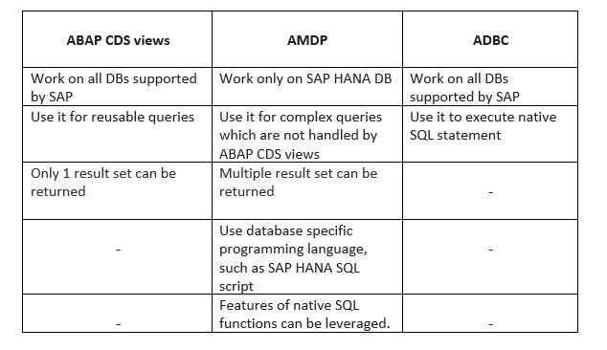

**When to use ABAP SQL, CDS views and AMDP**

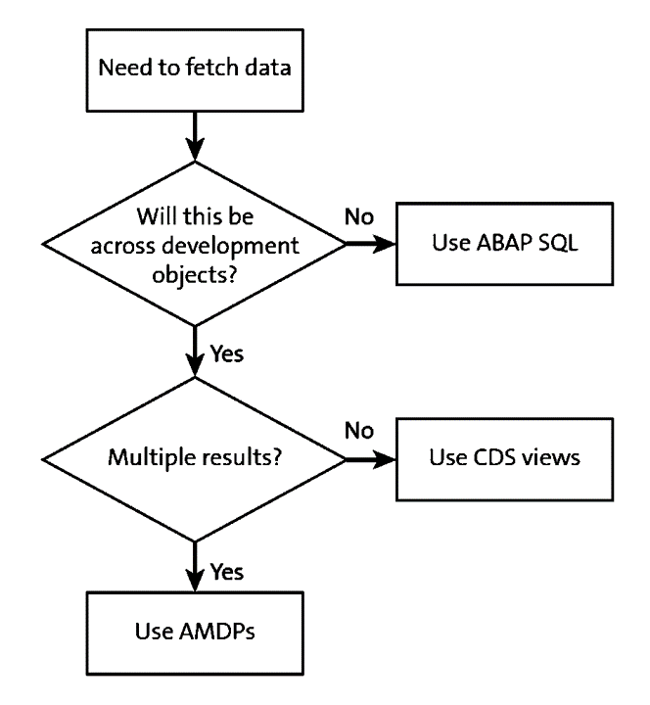

**11. What are the different types of CDS?**

       1. ABAP CDS

       2. HANA CDS

**12. Difference between ABAP CDS and HANA CDS ?**

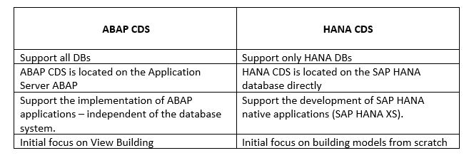

**13. Difference between ABAP dictionary view and ABAP CDS view?**

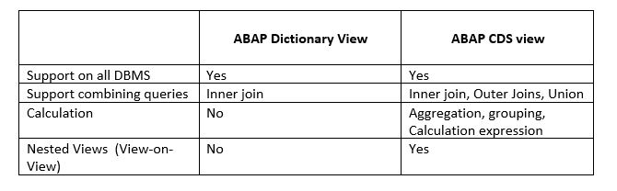

**14. What is ADT?**

Eclipse-based ABAP Development ABAP Development Tools (ADT) is an alternative to the ABAP Workbench.

ADT provides the following features:

● A complete new ABAP development experience on top of the Eclipse platform

● An open platform for developing new ABAP-related tools

● A set of open, language-independent, and platform-independent APIs that developers can use to build new custom tools for the ABAP environment

**15. Advantages of using ADT over ABAP workbench?**

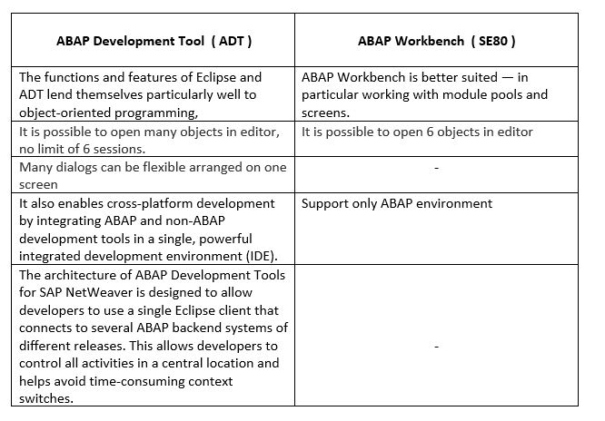

**16. What is Associations? How it is different from Join?**

An association defines relationship entities. An association associates the current CDS view as a source data source with the target data source target using an ON condition.

Although associations and joins look diﬀerent, there is no diﬀerence on the database level. Eventually, any association is translated into an ordinary join. But in the case of so-called exposed associations, it depends on the way a view is consumed. The join is only executed if the consumer requests data from the associated data source. This can have a positive effect on the performance and sometimes is referred to as “JOIN on Demand”.

Associations may contain additional semantic information such as cardinality.

**17. What are the types of associations?**

Ad-hoc association

Exposed association

Filtered association

**18. What is CDS Table Function?**

The AMDP framework supports AMDP functions alongside the existing AMDP procedures.

AMDP functions use the new addition BY DATABASE FUNCTION of the METHOD statement in AMDP classes.

AMDP functions are functional methods of global classes which deﬁne functions stored and executed on the database. It is not allowed to call functional methods that deﬁne AMDP functions directly in ABAP

ABAP CDS introduced CDS table functions to make AMDP functions available as data sources of SELECT statements.

**19. How ALV IDA is different from classical ALV?**

The classic ALV requires all data to be ﬁrst loaded into an internal table in order to display it. Typically, this is larger than what is actually displayed to the user. The initial load can lead to very long waiting times for the end-user or even short dumps due to memory consumption.

Once the data is loaded, all processing takes place in the ABAP stack on the internal table, for example, sorting the data set, ﬁltering the data set, grouping, aggregating, or adding calculated columns.

Clearly, the way in which the classical ALV works contradicts the new Code-to-Data approach. This is the reason for the new variant of the SAP List Viewer.

In ALV with integrated data access (ALV IDA), authority checks, sorting, ﬁltering the data set, grouping, aggregating and other processes that were previously carried out by the application are now performed by the database.

The amount of data is severely restricted by the database before it is displayed to a user, and there is no longer a need to store the displayed data inside an internal table.

**20. What is Union and union all?**

UNION joins the result sets of two queries.

The rows of the result set of the query after UNION are inserted into the result set of the query before UNION.

If the addition ALL is not speciﬁed, all duplicate entries are removed from the results set. They are not removed if ALL is speciﬁed.

**21. How CDS view and SQL view are related?**

A CDS View is deﬁned in a DDL Source, which is a new type of repository object.

Upon activation of a DDL Source, two objects are created: the SQL View and the CDS View.

The SQL View is visible as an object in the ABAP Dictionary where it cannot be edited and only reveals a fraction of the information available in the DDL source. It serves as a representative of the database object.

The CDS View carries more semantics than its SQL view. It is not created on the Database and it is not visible in the ABAP Dictionary. It can, however, be consumed via open SQL.

**22. What is the use of Annotation?**

Annotations enrich the CDS definition with metadata.

It starts with character @.

The annotation specifies the properties and semantics of an entity and its​​ behavior when it is consumed.​​

**23. What is the difference between AMDP procedure and AMDP function?**

